Ideation Phase
Define the Problem Statements

Date | 20 February 2026
Team ID | LTVIP2026TMIDS67101
Project Name | Weather-based prediction of wind turbine energy output: a next-generation approach to renewable energy management
Maximum Marks | 2 Marks

Customer Problem Statement
To define the core challenges faced by renewable energy analysts and students in predicting wind energy output using real-time weather conditions, and use those insights to guide the development of the Wind Energy Prediction system.
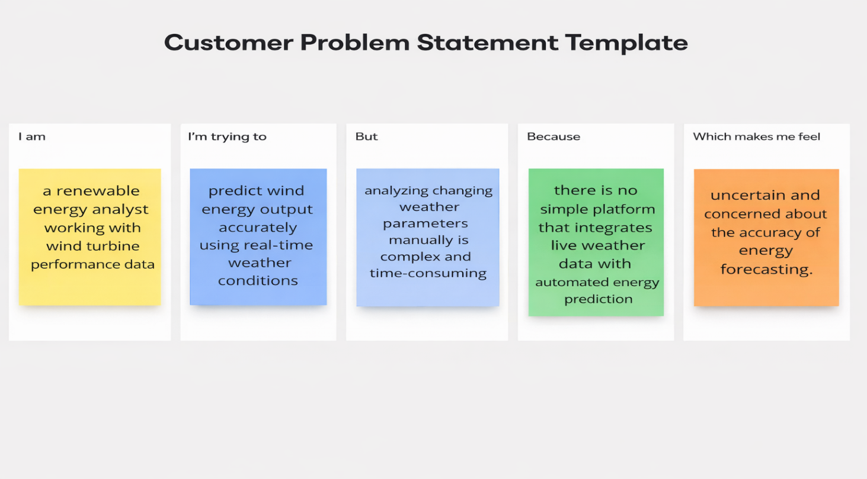
Reference: https://miro.com/templates/customer-problem-statement/

Problem Statement (PS) | I am (Customer) | I’m trying to | But | Because | Which makes me feel
PS-1 | a renewable energy analyst working with wind turbine performance data. | predict wind energy output accurately using current weather conditions. | weather parameters like wind speed and temperature change frequently and are difficult to analyze manually | there is no simple system that integrates live weather data with automated energy prediction | uncertain and concerned about the accuracy of energy forecasting.
PS-2 | a student researching renewable energy and machine learning applications. | understand how environmental factors affect wind energy generation. | most platforms either provide weather data or prediction models separately. | there is no integrated, easy-to-use web application combining both features. | limited and frustrated in analyzing real-time renewable energy performance.

